It still looks like this….



I believe that last time you helped me, I had something wrong on this page and that’s why it wouldn’t load. I’m not sure if whatever you changed didn’t stay changed or if I’m doing something else incorrectly. I think it may have been something to do with the source or branch drop down menus…???

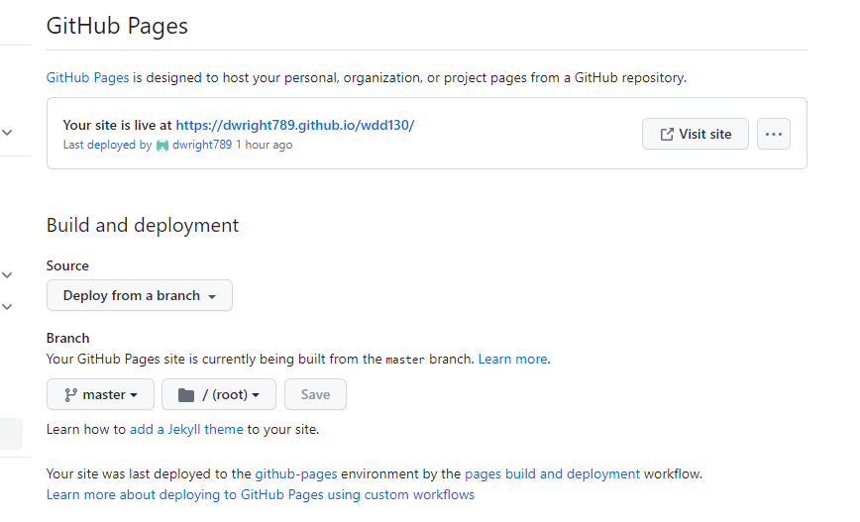

Here’s my current screen shot of this page showing that I recently committed new info.

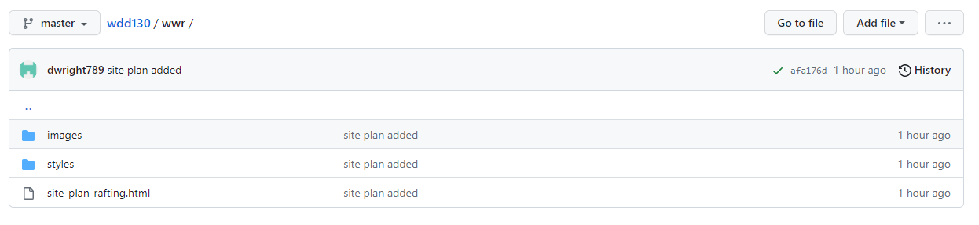

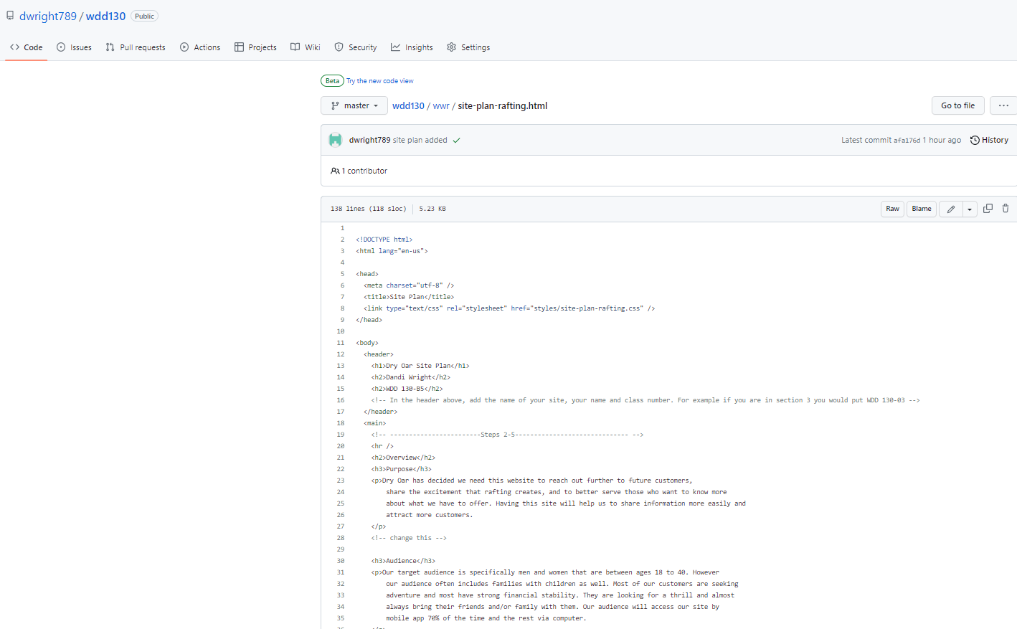

Here’s my live serve screen shot…

